Date 25/06/2026 LINUX VIDEO- 01 TASK

1 $ cat = it shows the inside information of file
2 $ mkdir = it is used to create new directory
3 $ cd = to change the current directory
4 $ cd ../ = one set back form current directory
5 $ date = is shows the today’s date
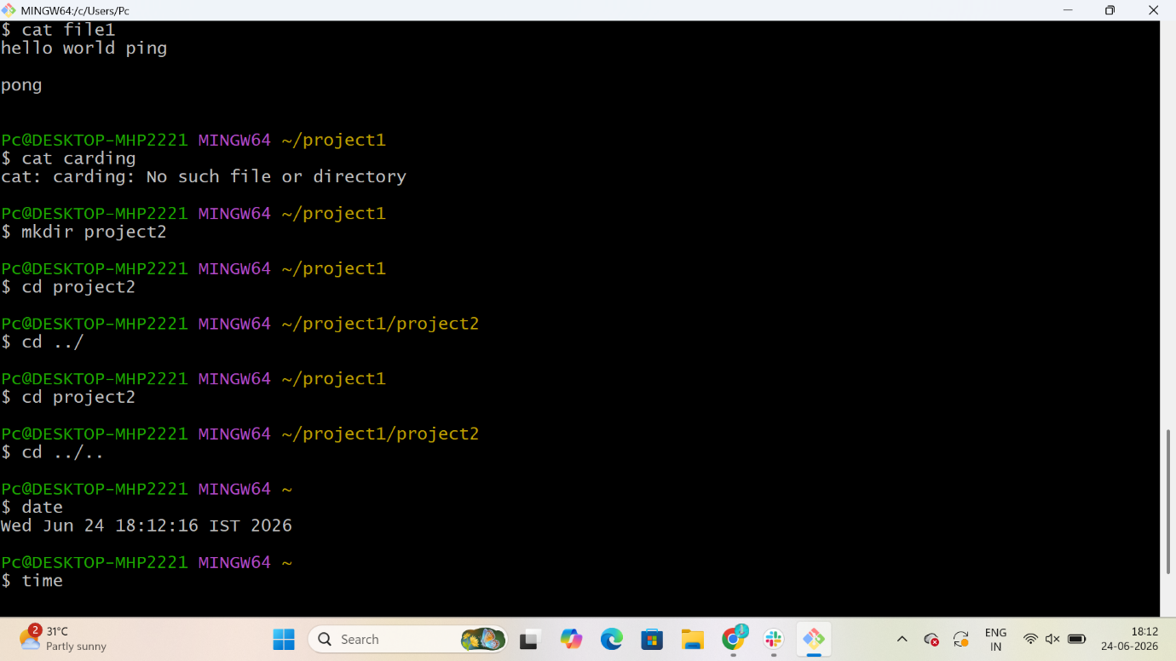

6 $ rm -rf = to delete the files and directorys
7 $ ls = it shows list of files
8 $ nano = it create a nano file
9 $ mv = it moves the data form one file to another file
10 $ cat = it shows the inside information of file with open it

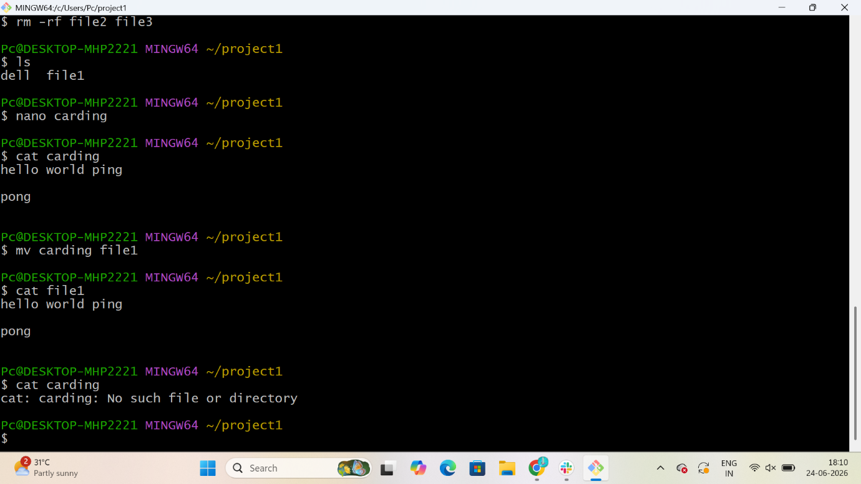
11 $ pwd = it shows the present working directory
12 $ cd = to change the directory
13 $ ls = is shows the list of files and directories
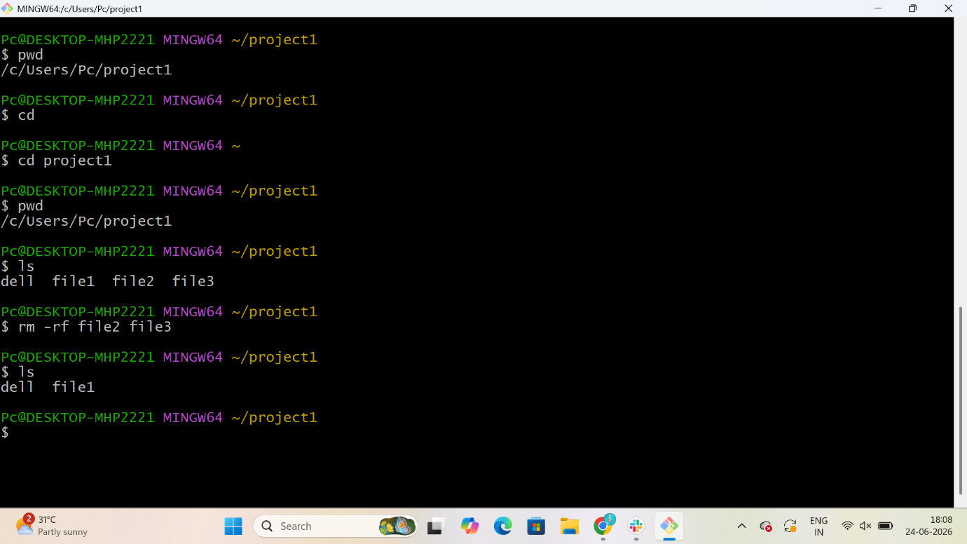

14 $ touch = to create the files
15 $ LL = it shows the long list of files with details
16 $ vi = it create the file and open the file
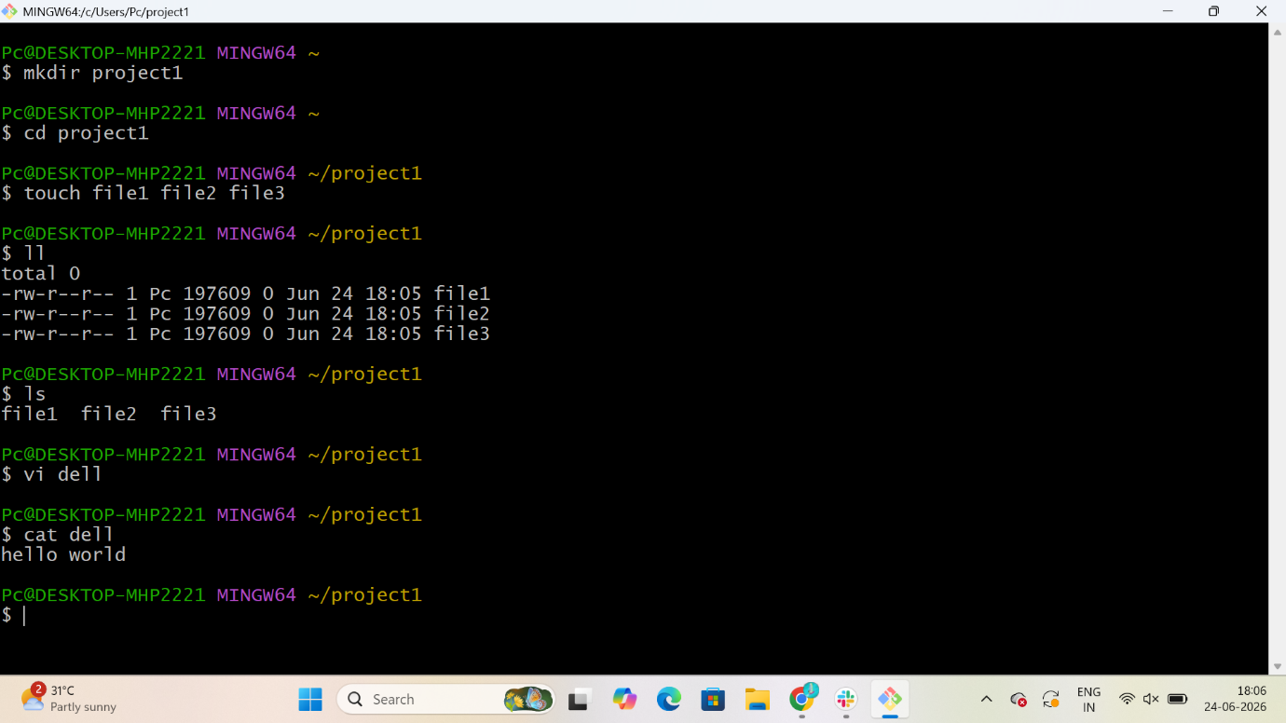
17 $ History = it shows the History of all executed commands
